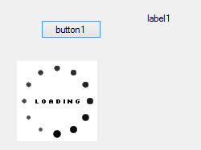

string cambio;

private void button1_Click(object sender, EventArgs e)

{

cambio = "";

pictureBox1.Visible = true;

Application.DoEvents();

// Add control backGroundWorker

backgroundWorker1.RunWorkerAsync();

}

private void backgroundWorker1_DoWork(object sender, DoWorkEventArgs e)

{

// Here it is not allowed to update any control on form which calls the thread

// update database, retrieve data

Thread.Sleep(6000);

// update global variables

cambio = "Process is over";

}

private void backgroundWorker1_RunWorkerCompleted(object sender, RunWorkerCompletedEventArgs e)

{

// when process is done, it is allow to update Controls in form

pictureBox1.Visible = false;

label1.Text = cambio;

}